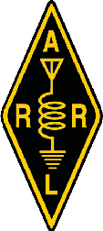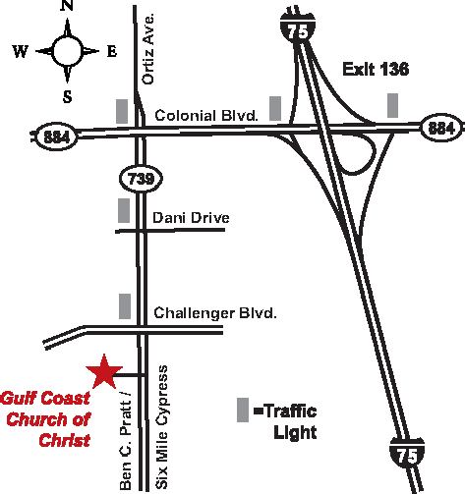Fort Myers, Florida January 20-21, 2017

SWFLHamfest.info

2017 SOUTHWEST FLORIDA HAMFEST

January 20-21, 2017
Gulf Coast Church of Christ at 9550 Six Mile Cypress Parkway • Fort Myers, FL
Just off of I-75, Exit 136. Talk-In Repeater: 147.345 (136.5 Tone)

FREE PARKING • Handicap Parking Available • $2,000 IN PRIZES!
Friday, January 20: Setup at 8 AM • Gates Open from Noon-5 PM
Saturday, January 21: Setup at 6 AM • Gates Open from 8 AM-3 PM

RAFFLE PRIZES and DOOR PRIZES!
over $2,000 in radios and prizes to be given away!

VISITOR INFORMATION
General Admission: Early Tickets by mail or from FMARC members: $5 • At the Gate: $7
Kids 12 & Under: FREE with Paying Adult • Students 13-18: $5 at Gate with Valid Student ID On-Site Security Provided • Great Food at Reasonable Prices From Food Truck On-Site FREE FCC LICENSE TESTING: Saturday, January 21, 2017 at 10 AM
ARRL Card Checking
VENDOR INFORMATION
Indoor Vendor Tables: $15 Each*
Commercial booth fees will be determined by space requested. Reserve Your Booth or Table Early for Best Placement!

Tailgate Spaces: $5* • Additional Tailgate Spaces: $5*
*All tailgate and indoor vendors must also purchase a General Admission ticket for each person in their party.

MAIL TICKET REQUESTS TO: FMARC PO Box 061183 Fort Myers, FL 33906
Please include SASE, otherwise tickets will be held at door. Cutoff date for receiving early ticket sales requests is Friday, January 13, 2017.
Need more information? Email: WO4K@arrl.net

